Recycling Machine System

M. Qasim
16053

Class Diagram
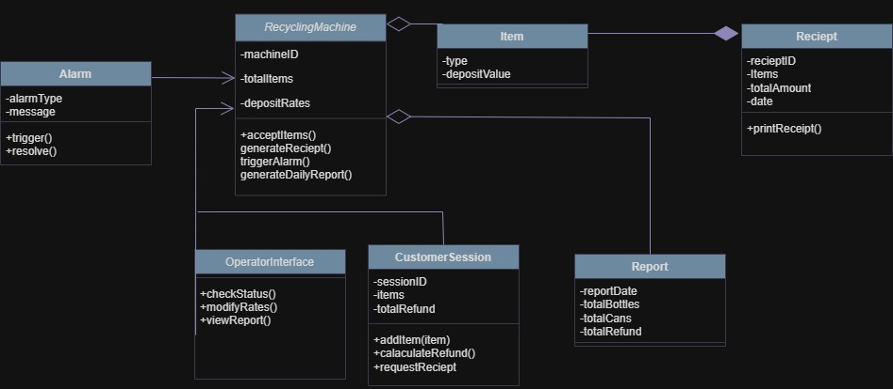

CODE:
using System;
using System.Collections.Generic;

namespace RecyclingSystem
{
// 1. Alarm Class
public class Alarm
{
// Attributes (Fields/Properties)
public string AlarmType { get; set; }
public string Message { get; set; }

// Methods
public void Trigger()
{
Console.WriteLine($"Alarm Triggered: {AlarmType} - {Message}");
// Actual implementation code would go here
}

public void Resolve()
{
Console.WriteLine($"Alarm Resolved: {AlarmType}");
// Actual implementation code would go here
}
}

// 2. Item Class
public class Item
{
// Attributes (Fields/Properties)
public string Type { get; set; } // e.g., "Bottle", "Can"
public double DepositValue { get; set; }

// Constructor
public Item(string type, double depositValue)
{
Type = type;
DepositValue = depositValue;
}
}

// 3. Reciept Class
public class Reciept
{
// Attributes (Fields/Properties)
public string RecieptID { get; set; }

// Relationship: Aggregation of Item objects
public List<Item> Items { get; set; } = new List<Item>();

public double TotalAmount { get; set; }
public DateTime Date { get; set; }

// Method
public void PrintReciept()
{
Console.WriteLine($"--- Reciept ID: {RecieptID} ---");
Console.WriteLine($"Total Refund: {TotalAmount:C}");
// Actual printing logic
}
}

// 4. Report Class
public class Report
{
// Attributes (Fields/Properties)
public DateTime ReportDate { get; set; }
public int TotalBottles { get; set; }
public int TotalCans { get; set; }
public double TotalRefund { get; set; }

// Method
public double CalaculateRefund()
{
// Simple example calculation
TotalRefund = (TotalBottles * 0.1) + (TotalCans * 0.05);
return TotalRefund;
}
}

// 5. OperatorInterface Class
public class OperatorInterface
{
// Methods
public void CheckStatus()
{
Console.WriteLine("Checking Recycling Machine status...");
}

public void ModifyRates()
{
Console.WriteLine("Modifying deposit rates...");
}

public void ViewReport(Report report)
{
Console.WriteLine($"Viewing report for: {report.ReportDate.ToShortDateString()}");
}
}

// 6. CustomerSession Class
public class CustomerSession
{
// Attributes (Fields/Properties)
public string SessionID { get; set; }

// Relationship: Holds items for the current session
public List<Item> Items { get; set; } = new List<Item>();

public double TotalRefund { get; set; }

// Methods
public void AddItem(Item item)
{
Items.Add(item);
Console.WriteLine($"Added {item.Type} with value {item.DepositValue:C}");
}

public double CalaculateRefund()
{
TotalRefund = Items.Sum(i => i.DepositValue);
return TotalRefund;
}

public Reciept RequestReciept()
{
var receipt = new Reciept
{
RecieptID = Guid.NewGuid().ToString(),
Items = this.Items,
TotalAmount = this.TotalRefund,
Date = DateTime.Now
};
return receipt;
}
}

// 7. RecyclingMachine Class (The main entity)
public class RecyclingMachine
{
// Attributes (Fields/Properties)
public string MachineID { get; set; }
public int TotalItems { get; private set; }

// Relationship: Deposit Rates (Item Type to Rate)
public Dictionary<string, double> DepositRates { get; set; } = new Dictionary<string, double>();

// Relationships (Composition/Association)
private Alarm currentAlarm;
public OperatorInterface OperatorInterface { get; set; } = new OperatorInterface();
private List<Report> dailyReports = new List<Report>();

// Constructor
public RecyclingMachine(string machineID)
{
MachineID = machineID;
// Initialize with some default rates
DepositRates.Add("Bottle", 0.10);
DepositRates.Add("Can", 0.05);
}

// Methods
public void AcceptItems(CustomerSession session)
{
Console.WriteLine($"Machine {MachineID} accepting items for session {session.SessionID}...");
TotalItems += session.Items.Count;
// Further processing...
}

public Reciept GenerateReciept(CustomerSession session)
{
session.CalaculateRefund();
Reciept receipt = session.RequestReciept();
Console.WriteLine("Receipt generated.");
return receipt;
}

public void TriggerAlarm(string type, string message)
{
currentAlarm = new Alarm { AlarmType = type, Message = message };
currentAlarm.Trigger();
}

public Report GenerateDailyReport()
{
// Example data simulation
var newReport = new Report
{
ReportDate = DateTime.Today,
TotalBottles = 150,
TotalCans = 200,
};
newReport.CalaculateRefund(); // Calculate refund before saving

dailyReports.Add(newReport);
Console.WriteLine($"Daily Report generated for {newReport.ReportDate.ToShortDateString()}.");
return newReport;
}
}
}

